Project Design Phase-II
Technology Stack (Architecture & Stack)

Date | 23 Jan 2026
Team ID | LTVIP2026TMIDS64924
Project Name | Smart sorting
Maximum Marks | 4 Marks

Technical Architecture:
The deliverable includes the architectural diagram (to be attached separately or drawn using tools like draw.io or Lucidchart) and the information filled in Table 1 and Table 2 below.
Example Scenario:
AI-based fruit and vegetable quality detection system deployed on a lightweight web app accessible to local vendors, using a trained transfer learning model for rotten/fresh classification.

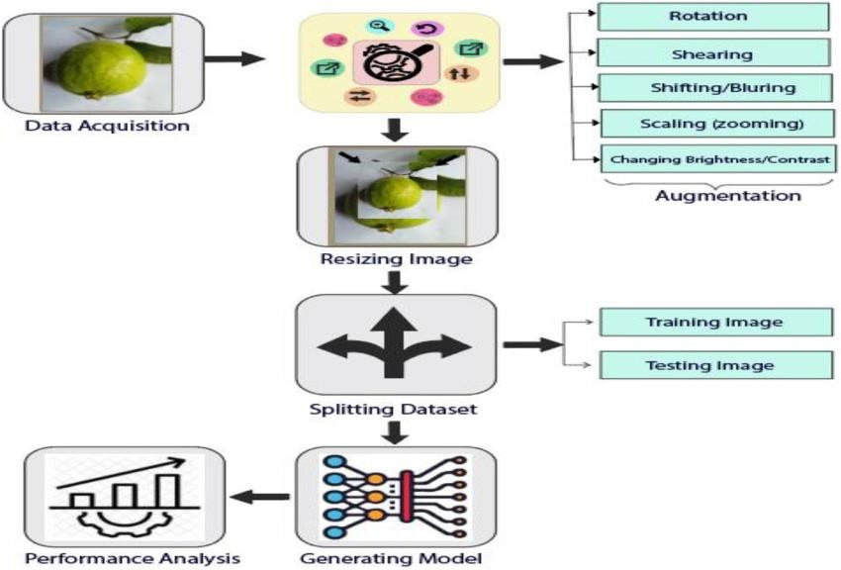 | Guidelines:  Include all the processes (As an application logic /  Technology Block)  Provide infrastructural demarcation (Local / Cloud) Indicate external interfaces (third party API’s etc.) Indicate Data Storage components / services Indicate interface to machine learning models (if applicable)

Table-1 : Components & Technologies:
S.No | Component | Description | Technology
1. | User Interface | Web interface for image upload and result view | . HTML, CSS, JavaScript
2. | Application Logic-1 | Image handling and routing | Python, Flask
3. | Application Logic-2 | Fruit classification logic | TensorFlow, Keras, VGG16 (Transfer Learning)
4. | File Storage | To temporarily store uploaded images | Local File System
5. | Machine Learning Model | Classify fresh vs. rotten fruits/vegetables | Object Recognition Model, etc.
6. | Infrastructure (Server / Cloud) | Deployment on Local System / Cloud Local Server Configuration:  Cloud Server Configuration : | Pretrained VGG16 model (.h5)

Table-2: Application Characteristics:
S.No | Characteristics | Description | Technology
1. | Open-Source Frameworks | Frameworks used for ML and web backend | Flask, TensorFlow, Keras
2. | Scalable Architecture | Clear separation of model, logic, and UI | 3-tier (UI, App Logic, Model
3. | Availability | Runs locally on student system | Localhost (127.0.0.1)
4. | Performance | Lightweight model and fast response | MobileNetV2 or optimized VGG16

